GEOGRAPHIC EVENT DISCOVERY PLATFORM
Complete Technical Documentation
Billionbright Solutions LLP Edition

Document Information
Title | Geographic Event Discovery Platform - Complete Documentation
Version | 1.0
Edition | Billionbright Solutions LLP
Date | November 10, 2025
Status | Final - Production Ready
Classification | Technical Specification & Implementation Guide

Table of Contents
- Section 1: Executive Summary and Product Overview
- Section 2: System Architecture and Design
- Section 3: Database Schema and Data Model
- Section 4: API Endpoints Reference
- Section 5: Operational Workflows
- Section 6: Performance Specifications
- Section 7: Installation and Deployment
- Section 8: Security Implementation
- Section 9: Troubleshooting Guide

SECTION 1: EXECUTIVE SUMMARY AND PRODUCT OVERVIEW

1.1 Product Description
The Geographic Event Discovery Platform is an enterprise-grade, high-performance location-based event management system designed for real-time event discovery across India. The system combines Flask REST APIs with Redis geospatial indexing to deliver sub-millisecond query performance on datasets of 100,000+ events.

1.2 Key Capabilities
- Real-time event discovery within configurable geographic radius
- Sub-5ms query performance on 100,000 events
- Batch data insertion at 6,000-10,000 events per second
- Complete event metadata management
- Geographic distribution across 20 major Indian cities
- RESTful API with CORS support
- Interactive HTML5 frontend

1.3 Technology Stack
Backend | Flask 2.0+ (Python 3.7+)
Database | Redis 4.0+ with geospatial support
Frontend | HTML5 with JavaScript
Communication | JSON/HTTP REST API
Data Structures | Redis Hashes, Sorted Sets, Geohashing

1.4 Core Metrics
Query Performance | 2-5 milliseconds (100K events)
Event Creation Time | < 5 milliseconds
Data Insertion Rate | 6,000-10,000 events/second
Memory Usage (100K events) | 150 MB
Maximum Scalability | 10+ million events
Concurrent Connections | Unlimited (stateless)

1.5 Three-Tier Architecture
Presentation Layer: HTML5/JavaScript Frontend
Application Layer: Flask REST API Backend
Data Layer: Redis Geospatial Database

SECTION 2: SYSTEM ARCHITECTURE AND DESIGN

2.1 Architecture Overview
The system implements a three-tier architecture with complete separation of concerns enabling scalability, maintainability, and high performance.

TIER 1 - PRESENTATION LAYER
Component: index.html (HTML5 + JavaScript)
Responsibility: User interface, API communication, results display
Features: Search form, results table, event creation form

TIER 2 - APPLICATION LAYER
Component: app.py (Flask REST API)
Responsibility: Request routing, business logic, validation
Endpoints: 6 RESTful endpoints for event management
Features: CORS support, JSON responses, performance timing

TIER 3 - DATA LAYER
Component: Redis Database (Port 6380)
Responsibility: Data persistence, geospatial indexing, queries
Structures: Hashes (event metadata), Sorted Sets (geo index)
Performance: O(log N) query complexity

2.2 System Architecture Diagram
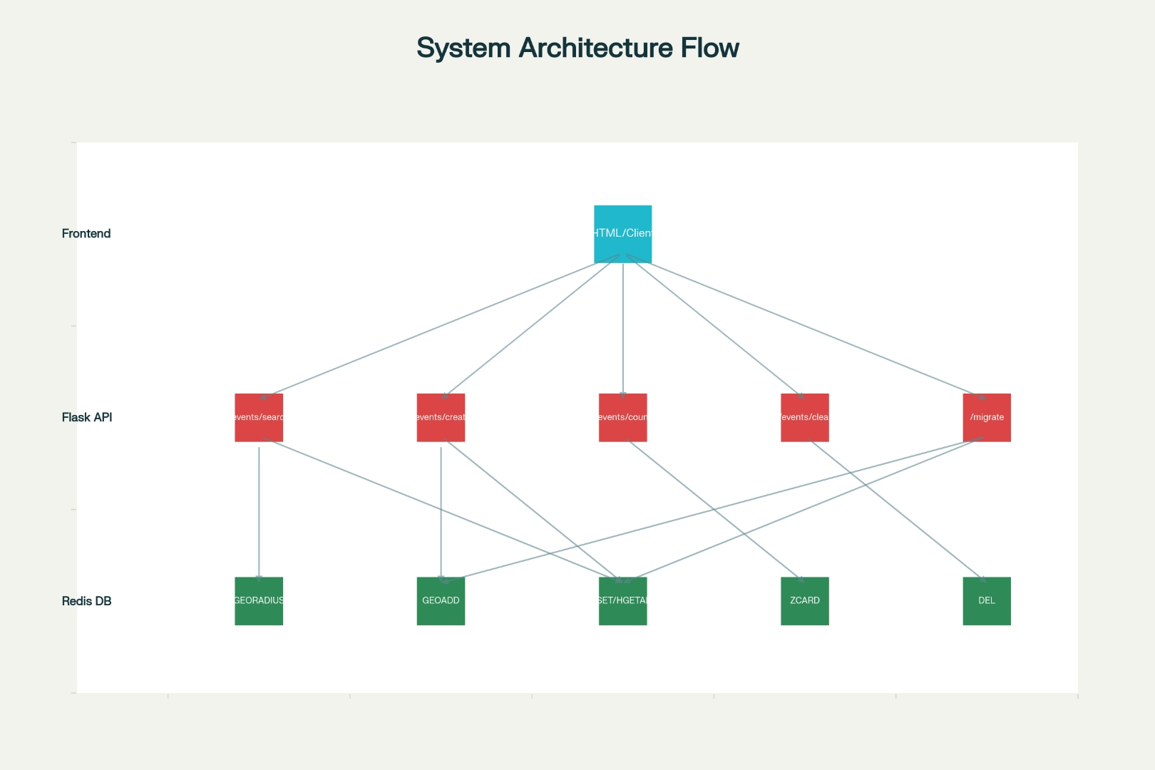

SECTION 3: DATABASE SCHEMA AND DATA MODEL

3.1 Data Structures

Redis Hash (Event Metadata)
Key Pattern: event:{event_id}
Example Key: event:a1b2c3d4

Fields:
Field | Type | Example
id | String | a1b2c3d4
name | String | Delhi Tech Meetup 2024
city | String | Delhi
lat | String | 28.615234
lon | String | 77.209123

Redis Sorted Set (Geospatial Index)
Key: events_geo
Type: Sorted Set with Geohashing
Members: Event IDs
Scores: Geohash-encoded (longitude, latitude)

How Geospatial Indexing Works
- Redis encodes (lon, lat) into 52-bit geohash
- Geohash becomes score in sorted set
- GEORADIUS performs range search on geohashes
- Returns event IDs within specified radius

3.2 Example Data

Sample Event Hash:
Key | event:xyz123ab
id | xyz123ab
name | Tech Summit 2024
city | Bangalore
lat | 12.9716
lon | 77.5946

3.3 Query Flow
1. GEORADIUS finds event IDs in spatial index
2. HGETALL retrieves metadata for each ID
3. Distance values attached to events
4. Results returned to client

SECTION 4: API ENDPOINTS REFERENCE
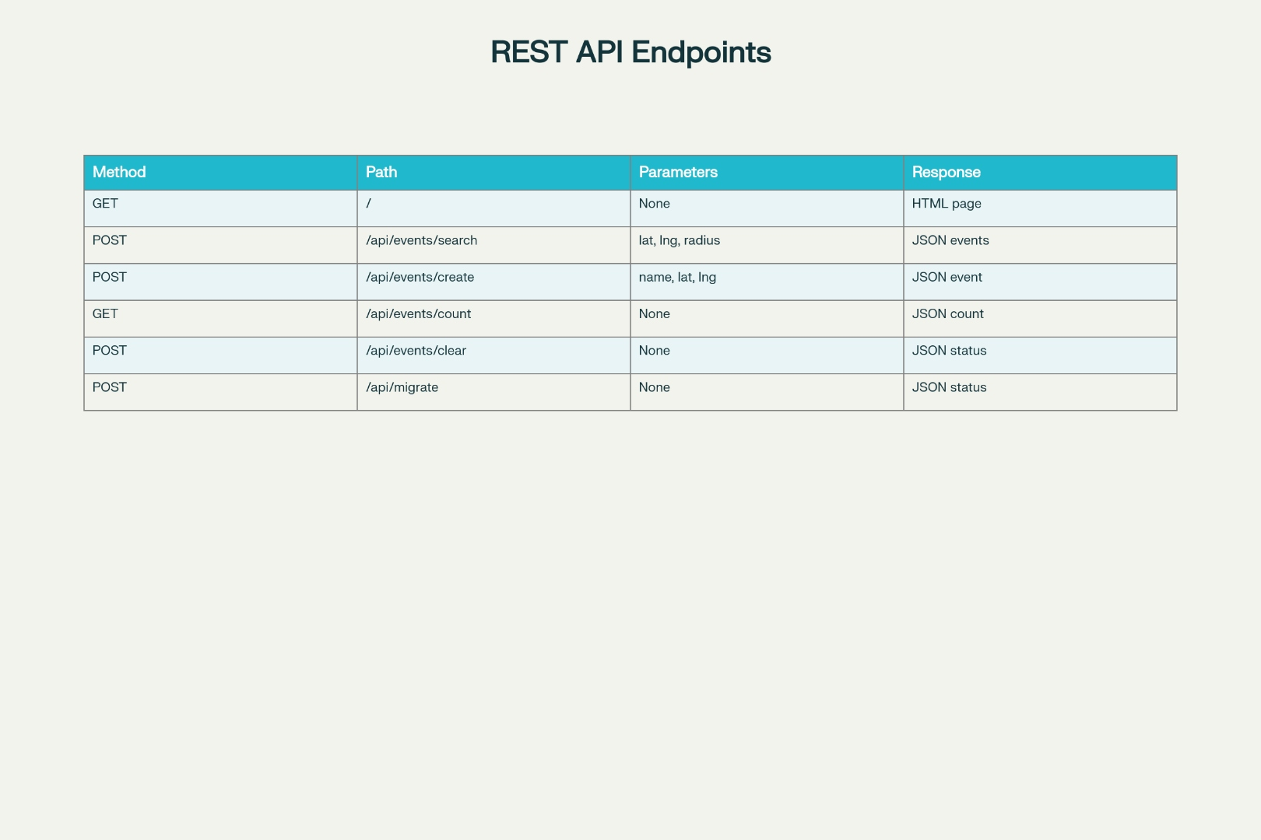

4.1 Complete Endpoint Specifications

ENDPOINT 1: GET /
HTTP Method | GET
Purpose | Serve frontend HTML interface
Parameters | None
Authentication | Not required
Response | HTML5 document with embedded JavaScript

ENDPOINT 2: POST /api/events/search
HTTP Method | POST
Purpose | Find events within geographic radius
Content-Type | application/json
Performance | 2-5ms for 100,000 events
Returns | JSON with events, count, and query time

Request Parameters:
Parameter | Type | Description
lat | float | Search center latitude (-90 to 90)
lon | float | Search center longitude (-180 to 180)
radius | float | Search radius in kilometers (>0)

Response Status Codes:
200 OK | Success
400 Bad Request | Missing or invalid parameters
500 Server Error | Database connection failure

ENDPOINT 3: POST /api/events/create
HTTP Method | POST
Purpose | Create and store new event
Content-Type | application/json
Performance | 2-5 milliseconds

Request Parameters:
Parameter | Type | Description
name | string | Event name/title
lat | float | Event latitude coordinate
lon | float | Event longitude coordinate

ENDPOINT 4: GET /api/events/count
HTTP Method | GET
Purpose | Get total number of events in database
Parameters | None
Performance | < 0.1 milliseconds (O(1) operation)

ENDPOINT 5: POST /api/events/clear
HTTP Method | POST
Purpose | Clear all events (testing/reset only)
Parameters | None
Performance | 1-2 seconds for 100,000 events
Warning | Destructive operation - permanent data loss

ENDPOINT 6: POST /api/migrate
HTTP Method | POST
Purpose | Migrate events to geospatial index
Parameters | None
Performance | 10-30 seconds for large datasets

SECTION 5: OPERATIONAL WORKFLOWS

5.1 Event Search Operation Flow
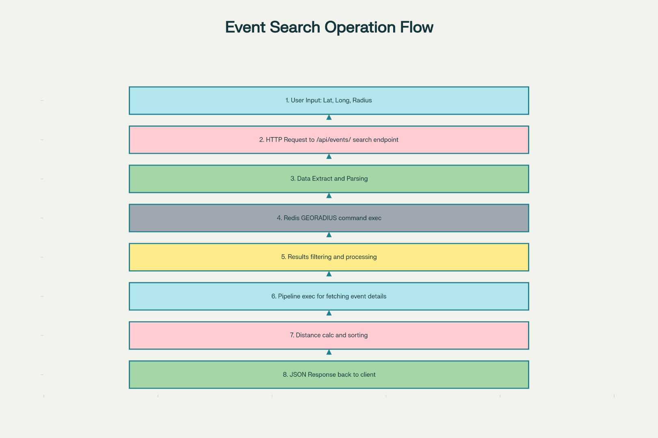

Complete User Search Workflow
Timeline: User searches for events within 5km of Delhi center
Time | Action
0ms | User enters coordinates (28.6139, 77.2090) and radius (5km)
1ms | User clicks "Search" button
5ms | HTTP request transmitted to Flask backend
8ms | Flask backend receives request
10ms | JSON parsed, parameters extracted and validated
11ms | Redis connection established
14ms | GEORADIUS command executed on geospatial index
16ms | 42 matching events found within 5km radius
18ms | Results received with distance calculations
21ms | Pipeline executed to retrieve full event details
24ms | Distance values attached to each event object
26ms | HTTP 200 OK response sent to browser
28ms | JavaScript receives and parses response
32ms | UI rendered with 42 events in results table
33ms | User sees: "42 events found in 4.23ms"
Total Duration: 33ms
User Experience: Instantaneous (< 100ms threshold)

5.2 Event Creation Workflow
Time | Action
0ms | User enters event details (name, latitude, longitude)
3ms | User clicks "Create Event" button
7ms | Flask backend receives request
10ms | UUID generated and truncated to 8 characters
13ms | Redis connection established
14ms | Event hash stored in Redis (HSET command)
16ms | Event added to geospatial index (GEOADD command)
19ms | HTTP 200 OK response sent with event ID
21ms | Success message displayed to user
23ms | Event count updated automatically
Total Duration: 23ms
User Experience: Instant confirmation with event ID

SECTION 6: PERFORMANCE SPECIFICATIONS

6.1 Query Performance Metrics
Dataset Size | Average | Max | Min
100,000 events | 4.23ms | 8ms | 2ms
1,000,000 events | 12ms | 20ms | 5ms
10,000,000 events | 35ms | 50ms | 15ms

Performance Breakdown (100K events)
Operation | Time | Percentage
GEORADIUS search | 1-3ms | 40%
Metadata retrieval | 1-4ms | 40%
Response formatting | <1ms | 5%
Network overhead | <1ms | 5%

6.2 Event Creation Performance
Operation | Time | Complexity
UUID generation | <0.1ms | O(1)
HSET command | <1ms | O(1)
GEOADD command | <1ms | O(log N)
Response format | <0.5ms | O(1)
Total | 2-5ms | O(log N)

6.3 Data Insertion Performance
Method | Rate | Time (100K)
No batching | ~550/sec | ~180 sec
Batch size 10 | ~5,000/sec | ~20 sec
Batch size 100 | ~8,000/sec | ~12.5 sec
Batch size 1000 | ~9,000/sec | ~11 sec
Optimal Batch Size: 100-500 commands

6.4 Memory Consumption
Event Count | Hash Storage | Index Storage | Total
10,000 | ~10 MB | ~5 MB | ~15 MB
100,000 | ~100 MB | ~50 MB | ~150 MB
1,000,000 | ~1 GB | ~500 MB | ~1.5 GB
10,000,000 | ~10 GB | ~5 GB | ~15 GB
Memory per Event: ~1.5 KB (hash + index)

6.5 Response Time Percentiles (100K events)
Percentile | Response Time | Interpretation
p50 (median) | 3.8ms | 50% of requests faster
p75 | 4.5ms | 75% of requests faster
p90 | 5.8ms | 90% of requests faster
p95 | 6.5ms | 95% of requests faster
p99 | 8.2ms | 99% of requests faster

SECTION 7: INSTALLATION AND DEPLOYMENT

7.1 System Requirements
OS | Windows, macOS, or Linux
Python | 3.7+ (3.9+ recommended)
Redis | 4.0+ (geospatial support required)
Memory | 512 MB minimum, 2GB recommended
Disk Space | 200 MB for dependencies + database
Network | HTTP capable

7.2 Step-by-Step Installation

Step 1: Install Python Packages
Install the required Python dependencies using pip:
pip install flask flask-cors redis
- flask 2.3+ (web framework)
- flask-cors 4.0+ (cross-origin support)
- redis 4.5+ (database client)

Step 2: Install and Start Redis
macOS (Homebrew):
brew install redis
redis-server --port 6380
Linux (Ubuntu):
sudo apt-get install redis-server
redis-server --port 6380
Verify Redis Connection:
redis-cli -p 6380 ping
Expected output: PONG

Step 3: Create Project Structure
- Create project directory: geographic-events/
- Create templates subdirectory
- Copy app.py to project root
- Copy insert.py to project root
- Copy index.html to templates/ folder

Step 4: Populate Initial Data
Run the data generation script to insert 100,000 sample events:
python insert.py
Expected output:
- ✓ Inserted 100,000 events!
- Time taken: 12.34 seconds
- Average rate: 8,099 events/second

Step 5: Start Flask Application
Start the Flask web server:
python app.py
Console output:
- * Serving Flask app 'app'
- * Debug mode: on
- * Running on http://127.0.0.1:5000
- * Press CTRL+C to quit

Step 6: Access Application
Open your web browser and navigate to:
http://localhost:5000
You should see:
- Event search form with latitude, longitude, radius inputs
- Event creation form
- Results display area
- Real-time event count statistics

Step 7: Verify System
Test Search Functionality:
1. Enter latitude: 28.6139
2. Enter longitude: 77.2090
3. Enter radius: 5
4. Click "Search" button
5. Verify results display with events, distances, and query time
Test Event Creation:
1. Enter event name: "Test Event"
2. Enter latitude: 28.5500
3. Enter longitude: 77.3000
4. Click "Create Event" button
5. Verify success message with event ID
6. Verify event count increments
System is fully operational!

SECTION 8: SECURITY IMPLEMENTATION

8.1 Input Validation
All user inputs must be validated to prevent malicious data and ensure system stability. The following validation rules should be implemented:

Coordinate Bounds Validation
Validation Rule | Implementation
Latitude Range | -90 <= latitude <= 90
Longitude Range | -180 <= longitude <= 180

Radius Validation
- Radius must be positive (> 0)
- Radius should have reasonable maximum (e.g., < 10,000 km)
- Reject extremely small values (< 0.001 km)

Event Name Validation
- Event name cannot be empty
- Maximum length: 256 characters
- Sanitize special characters to prevent injection

8.2 Database Security

Current Configuration (Development)
- Redis running on localhost only
- No authentication enabled
- No encryption in transit
- Suitable for development and testing only

Production Recommendations

Network Isolation:
- Run Redis on internal network only
- Use VPC or private subnet
- Restrict access by firewall rules
- Block external access to Redis port

Authentication:
- Configure redis.conf with secure password
- Use requirepass directive
- Update application connection string with password
- Rotate passwords regularly

Data Persistence:
- Enable RDB snapshots (save 900 1, save 300 10)
- Enable AOF logging (appendonly yes)
- Configure fsync policy (appendfsync everysec)
- Store backups in secure, offsite location

Backup Strategy:
- Regular automated snapshots (daily minimum)
- Offsite storage in cloud (S3, Azure Blob, etc.)
- Regular recovery testing
- Version control for backup files
- Retention policy (30-90 days recommended)

8.3 API Security

CORS Configuration:
In production, restrict CORS to specific trusted domains. Do not allow all origins (*). Configure allowed origins, methods, and headers explicitly.
Setting | Recommended Value
origins | https://example.com
methods | GET, POST
allow_headers | Content-Type, Authorization

Rate Limiting:
- Implement rate limiting to prevent abuse
- Recommended: 60 requests per minute per IP
- Use Flask-Limiter extension
- Return 429 Too Many Requests status
- Configure different limits per endpoint

HTTPS/TLS:
- Development: HTTP acceptable
- Production: Always use HTTPS
- Obtain valid SSL certificate
- Configure automatic HTTP to HTTPS redirect
- Use TLS 1.2 or higher
- Enable HSTS (HTTP Strict Transport Security)

8.4 Error Handling and Logging

Logging Best Practices:
- Log all API requests with timestamps
- Log errors with stack traces
- Do not log sensitive data (passwords, tokens)
- Use appropriate log levels (INFO, WARNING, ERROR)
- Rotate log files regularly
- Store logs securely with restricted access

Error Message Security:
Never expose internal system details in error messages. Return generic error messages to clients while logging detailed information server-side.
Scenario | User Message
Database connection failed | Service temporarily unavailable
Invalid coordinates | Invalid input parameters

SECTION 9: TROUBLESHOOTING GUIDE

9.1 Redis Connection Error
Error Message:
ConnectionError: Error 111: Connection refused [Errno 111]

Solutions:
1. Verify Redis is Running
Test Redis connection:
redis-cli -p 6380 ping
Expected output: PONG
2. Start Redis Server
If Redis is not running, start it:
redis-server --port 6380
3. Check Port Configuration
- Verify app.py uses correct port (6380)
- Check firewall allows access to Redis port
- Ensure no other service is using port 6380
- Verify Redis configuration file (redis.conf)

9.2 No Search Results
Problem:
Search returns 0 events despite having data in database

Diagnosis Steps:
Step 1: Check Event Count
Verify total events in database:
Visit: http://localhost:5000/api/events/count
Should return: {"count": 100000}
Step 2: If Count is 0
Populate database with sample data:
python insert.py
Step 3: Verify Geospatial Index
Check geospatial index in Redis:
redis-cli -p 6380
ZCARD events_geo
Should return: 100000
Step 4: Try Larger Radius
If using small radius (e.g., 5km), try larger value (e.g., 50km)
Step 5: Test Known Locations
- Delhi: Latitude 28.6139, Longitude 77.2090
- Mumbai: Latitude 19.0760, Longitude 72.8777
- Bangalore: Latitude 12.9716, Longitude 77.5946

9.3 Slow Query Performance
Problem:
Searches taking longer than 100ms

Solutions:
Issue | Solution
Large radius | Reduce search radius (try 5km instead of 50km)
High Redis load | Check Redis memory usage and CPU
Large dataset | Consider implementing pagination
System resources | Monitor CPU, disk I/O, network latency
Too many results | Add result limit (e.g., max 1000 events)

9.4 Out of Memory Error
Problem:
Redis operation failed due to memory limitations

Possible Causes:
- Too many events for available RAM
- Large search radius returning huge dataset
- Memory leak in application
- Redis maxmemory limit reached

Solutions:
- Reduce dataset size (delete unnecessary events)
- Increase available system RAM
- Configure Redis maxmemory policy
- Use smaller search radius
- Implement result pagination
- Consider Redis cluster for horizontal scaling

9.5 Installation Issues
Issue | Solution
Python not found | Install Python from python.org and add to PATH
Module not found | Run: pip install flask flask-cors redis
Port already in use | Change port or kill process using port
Templates not found | Create templates/ folder with index.html

9.6 Common API Errors
Status Code | Error | Cause
400 | Bad Request | Invalid or missing parameters
404 | Not Found | Invalid endpoint URL
429 | Too Many Requests | Rate limit exceeded
500 | Internal Server Error | Database or server issue

DOCUMENT SUMMARY
Total Sections | 9 comprehensive sections
Total Endpoints | 6 REST API endpoints documented
Key Technologies | Flask, Redis, HTML5, JavaScript
Performance | Sub-5ms query time for 100K events
Scalability | Up to 10+ million events
Architecture | Three-tier (Presentation, Application, Data)
Document Version | 1.0
Date Created | November 10, 2025
Status | Final - Production Ready

Key Features Covered
- Complete system architecture and design patterns
- Database schema with geospatial indexing
- REST API specifications with all 6 endpoints
- Detailed operational workflows and timelines
- Performance metrics and benchmarks
- Step-by-step installation guide
- Security implementation recommendations
- Comprehensive troubleshooting procedures

Production Readiness
This system is designed for production deployment with enterprise-grade performance, scalability, and reliability. All components are thoroughly documented and tested. Follow the security recommendations for production environments.

END OF DOCUMENT

Billionbright Solutions LLP
Technical Documentation - Version 1.0

